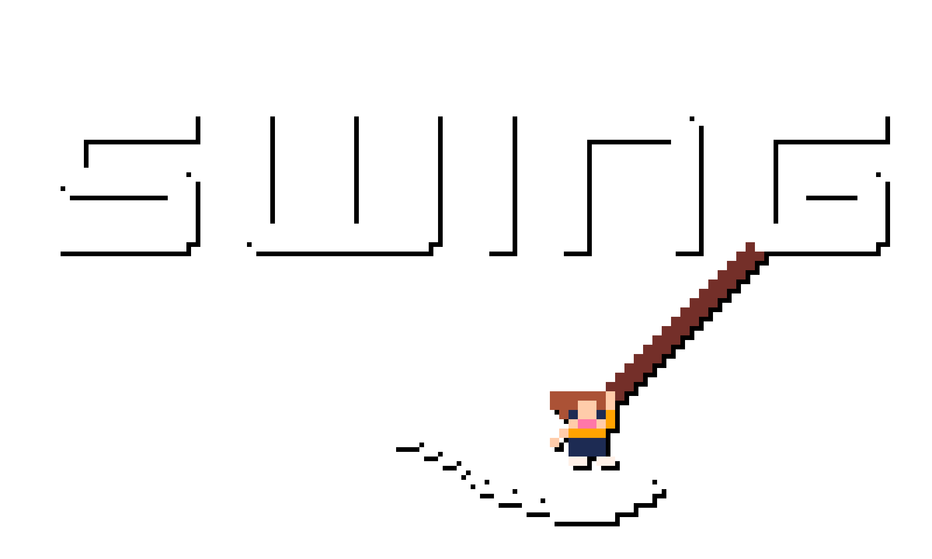

OCR, A-Level, Programming Project, 2021 – 2023, write-up, including analysis, design, development, and evaluation.
Malachy Moran-Tun Candidate #6178

3.1. Analysis of the Problem

3.1.1. Problem Identification
Platformer games are one of the most fundamental gaming genres; everyone has played at least one platformer, whether it’s the original Super Mario Bros. on the Nintendo Entertainment System, or a much more recent one, such as Celeste. Nevertheless, the central mechanics of running and jumping, getting round obstacles to explore and/or reach the end of a level, have remained integral to gaming.
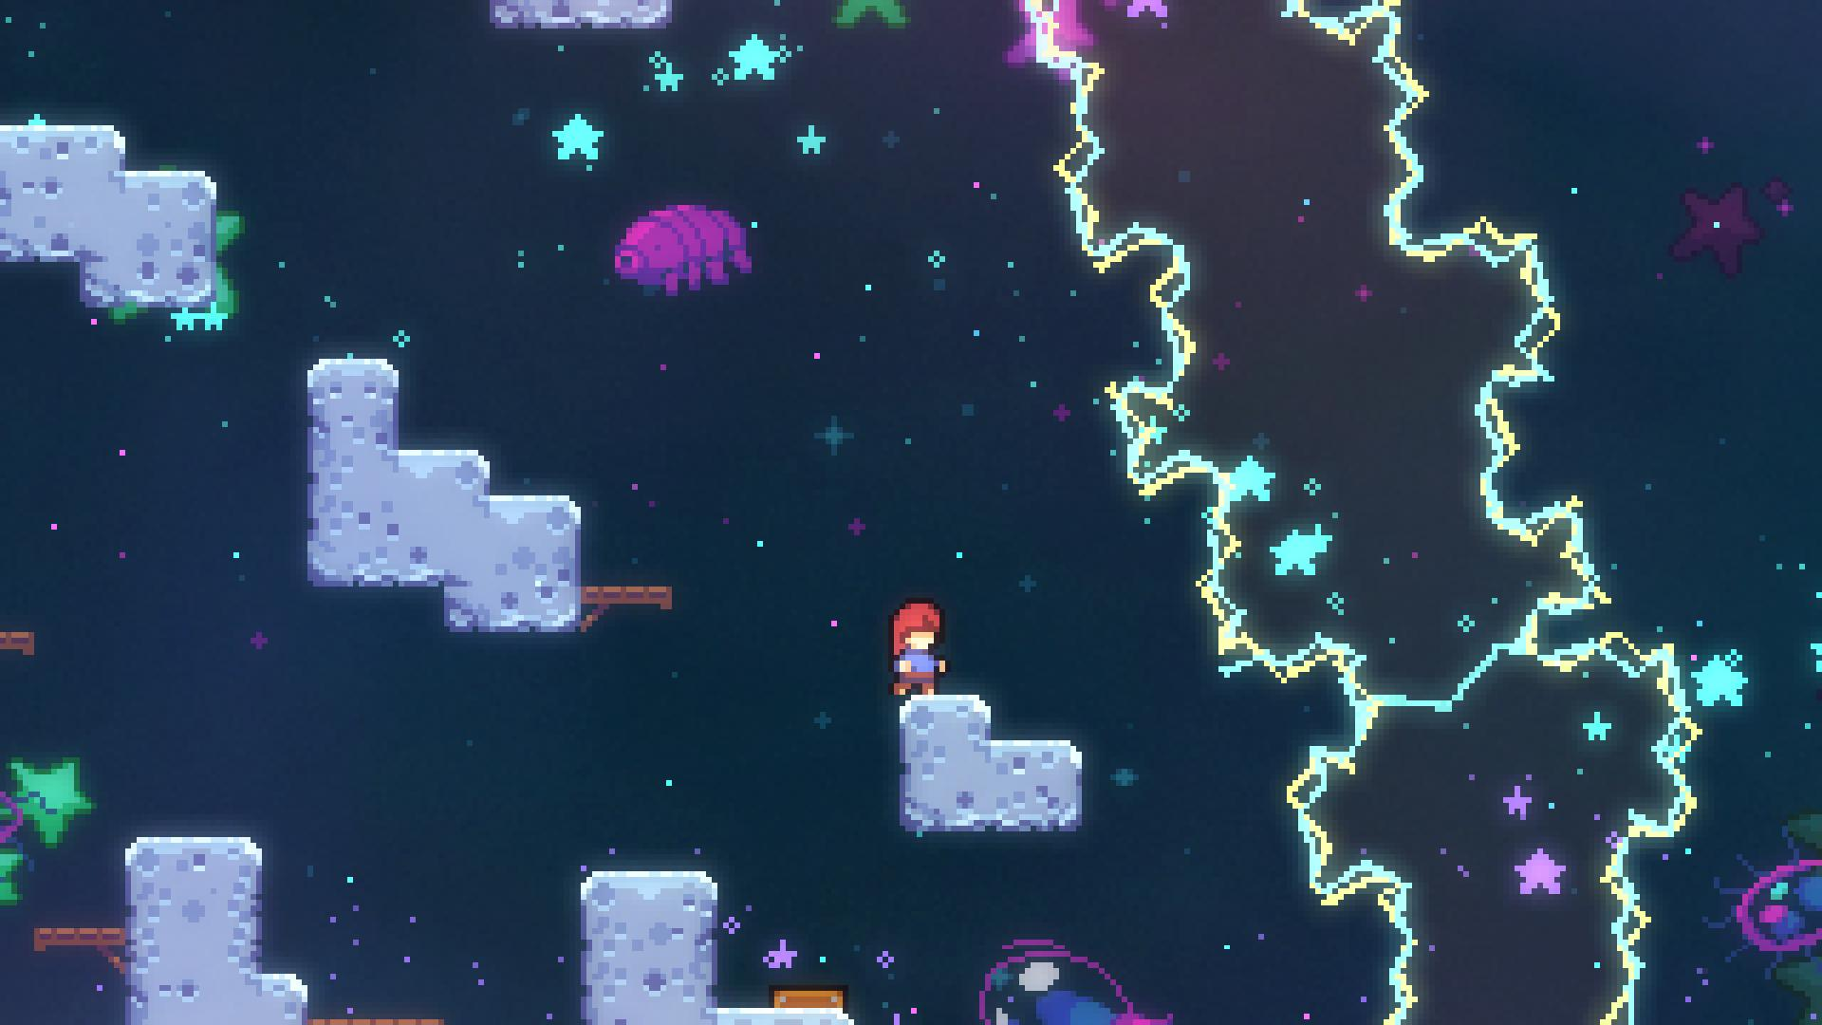
The retro-styled, indie, platformer market is initially thought of as over-saturated, since it is the first genre of game that comes to mind for new game developers. Because of this insanely awesome but difficult to design genre, many have made the connection between bland gameplay, generic graphics graphics and platformers. However, thankfully, games like Celeste, Spelunky, Hollow Knight, Shovel Knight, VVVVVV, and more have brought precise, tight jumps back into the market’s interest, with more coming on the horizon, like Pokey Poke and Hollow Knight: Silksong.
Taking Celeste, for an example, it’s primary platforming focus is the ability to dash: a common mechanic, but it was so integral to the gameplay that now games with a dash mechanic are instantly compared to Celeste. I plan to make my “primary mechanic” be a grapple hook, or rope swing ability, i.e., the player has the ability to swing off platforms, as well as grab and move objects. Certain terrain / ground types may not be able to be grappled on to, however, in order to maintain the platforming challenge.
I intend to create a game in similar vein to the games mentioned above, with a well-planned out difficulty progression, as created by slowly bringing in platforming concepts, without going too far. Quality of life improvements would include: auto-tiling, pixel-perfect collision detection, sprite animations, as well as more platformer specifics, such as variable jump height, buffering inputs, friction (or some amount of acceleration), mid-air turning etc..
The main gimmick of my game, a “grappling hook”, from which the player can swing from to reach different parts of the level, will interact with more than just the ground of the level, for example, the player might need to use it to hit a button then swing from a platform in quick succession. Essentially, it will be the central focus, and the level design will be focused on that, as well as all the enemies / level objects.

3.1.2. Stakeholders
The retro-inspired mechanics, music, sound design, and graphics create a broad target audience that, at first, may seem over-saturated in the market. However, this is simply because it’s much easier to create coherent sprite and gameplay design when keeping it similar to older-styled games. Whilst at first, it may seem difficult to “stick out” because of this, the majority of the target audience will only play a small selection of these retro-styled games, as well as the majority of triple A games. This means that, if anything, it is much more difficult for a generic 3D game with default assets, rather than a well-defined 2D game, to stick out. I intend to create a game to be played on PC / Mac / Linux machines, primarily because they are open to develop for, and offer versatility in graphics, sound, and control management.

Due to the more complex controls, as well as the planned difficulty, the target audience is anyone above and around 12 years old; even though, traditionally, a game similar may have a lower age rating, even going to 3+, due to the non-violent and inoffensive graphics, I plan on maintaining a “tough but fair” level design philosophy, similar to that of early Mario games (e.g., SMB3 / SMW) and Celeste.

3.1.2. Solving the Problem using Computational Methods
Computational methods can aid in creating this game, especially in time constraints, as well as any programming, art, sound, and music constraints I may face. The problem itself can be easily managed by breaking it down into its core elements, and slowly tackling each small part at a time. Moreover, abstracting the problem, and thinking logically and concurrently, will also help me throughout the project.

Thinking Ahead
Thinking ahead is the process of identifying important, core information about the solution, which provides the necessary structure to then create a detailed solution. The below points explain the core elements of my solution:
- The game will be created in the “Godot” game engine, which is an open-source, object oriented, game engine, coded using GDScript, which is a language syntactically similar to python, with the flexibility of C#.
- I plan on using both a keyboard and mouse to control the game, with the keyboard controls being able to be “rebound”, meaning I will have to create the necessary systems to easily change the controls whilst playing the game.
- The game will output to a monitor, as well as have sound. However, I plan on making sound optional, meaning the game must be designed around primarily visuals, with sound being for additional feedback.
- I plan on implementing a score system that is entirely optional, and community driven, meaning it is up to the players playing the game to create challenges based off the information provided from the game.

Thinking Abstractly
Abstraction is the removal of any unnecessary details and elements of a problem for the purpose of keeping the problem simple and easy to manage, whilst still retaining the core, essential details. This doesn’t necessarily mean removing features, but rather designing the game’s features around this clean and simple thinking. I plan to design my game with the following abstractions:
- 2D – I have never created a 3D game, meaning restricting it to 2D means I’ll be able to understand the rendering of sprite and game objects much easier. It removes an additional axis, making it much easier to design and program.
- Pixel art – hand drawn art, or pre-rendered 2D sprites, are something I have never created; thus, I will design my game around the classic 1980s / early 1990s look, which has become a staple in modern indie titles. This will make it easy for the player to understand what each part represents, as it will force the graphics to have a simplistic art-style.
- “Hitboxes”, or collisions for the ground and enemies will be invisible rectangles, or similar shapes, as is common with many games, to allow it to run on lower spec. machines, as well as make it easier to program
- Menu – provide customisations, such as control options, and accessibility settings – perhaps including an “assist mode”
- Pause button – allow the player to pause the game to do something else, but also provide the player a way of changing options mid-game, as well as exiting the game
- Gravity will not work consistently, in order to provide more control over the player whilst on the rope, as compared to on the ground, and jumping.

Thinking Concurrently
Concurrency allows for the processing of multiple instructions at the same time. Crucially, this has to be designed into the software in order to take advantage of it. Concurrent processing is not required for this problem, as the game logic can be handled all in one frame (^{th} of a second), and then displayed.
Concurrency will be required for displaying multiple parts of the graphics at the same time (e.g., the player and the tiles), as well as to handle any music and sound in the game. However, logic to initialise and control these different parts does not have to be handled concurrently, since all logic can be done in a single frame. Similarly, concurrency will allow for multiple sounds to be played simultaneously, meaning the game can play music as well as sound effects, without removing audio channels in the process.

Thinking Procedurally and Decomposition
Decomposition is the process of breaking down a large problem into a series of more manageable problems; the solutions of which will build up the final solution to the original large problem – in this case, the game.
- Due to the object-oriented nature of the game engine, I have chosen to use, Godot, decomposition can occur quite naturally, as the problem is already broken down into separate classes, which can be re-used throughout the game .
- Inheritance will also be used to inherit core methods and attributes, most importantly, the position of various objects in the game. This will allow for one object to contain a sprite, collision information, and animation, all of which will follow the same position .
- The player will also use a “state-machine” to switch between two main states: basic platformer movement, and rope-swing movement. This breaks down the overall task of player movement into two smaller, and subsequently easier to solve problems, as well as provides a larger amount of overall control when creating the player .

Thinking Logically
Logical thinking is an important step in creating any effective final product – in this case, a game. Because the game requires inputs to be fetched every frame, as well as “physics” based code, such as movement, gravity, and the rope swinging code, thinking logically is imperative to a successful product.
- A “main” game loop needs to be processed every frame. This will use delta time to correctly calculate the game’s physics, regardless of the framerate
  - Inside this main loop will be a “state machine”, which will change what piece of code it’s running based on a single “state” variable. This allows completely separate physics logic for the platformer state, and the rope swing state.
- Several conditions for controls must be added to allow for the game to react to inputs
- Conditions are required to correctly animate the player, switching between different player states
- A condition to test whether the player is on the ground will be necessary for jumping logic
- There must be logic to stop the player’s speed from indefinitely increasing

3.1.3. Research the Problem

Comparison of Retro-Styled Platformers
As very often mentioned in this document, my main inspirations are games like Hollow Knight, Celeste, the classic Mario games (i.e., SMB, SMB2, SMB3, SMW, SML, SML2), and the classic Sonic “trilogy” (Sonic 1, 2, CD, and 3, as well as their 8-bit counter parts). There is a significant difference between the classic and modern platformers, at first sight (mainly the age, of course), but the core mechanics that are integral to the experience are shared, even 30+ years later.
To simplify the analysis of key mechanics, including how the user experience feels, the graphical user interface is implemented, and communication of important story and/or mechanics, I will focus my analysis on Celeste, mainly concentrating on the following important elements:
- The tutorial, and its communication with the player
- The mechanics in Celeste
- The presentation of Celeste, including the user experience and GUI elements

The Tutorial and its Communication with the Player
Celeste’s tutorial is extremely simple, and acts mainly as a story element. Celeste’s main mechanic is the dash, however it pairs well with the wall-jumping and climbing mechanic. Since climbing is much more simple and more common than dashing, Celeste opts for allowing the user to test this out in a small screen just after pressing start.
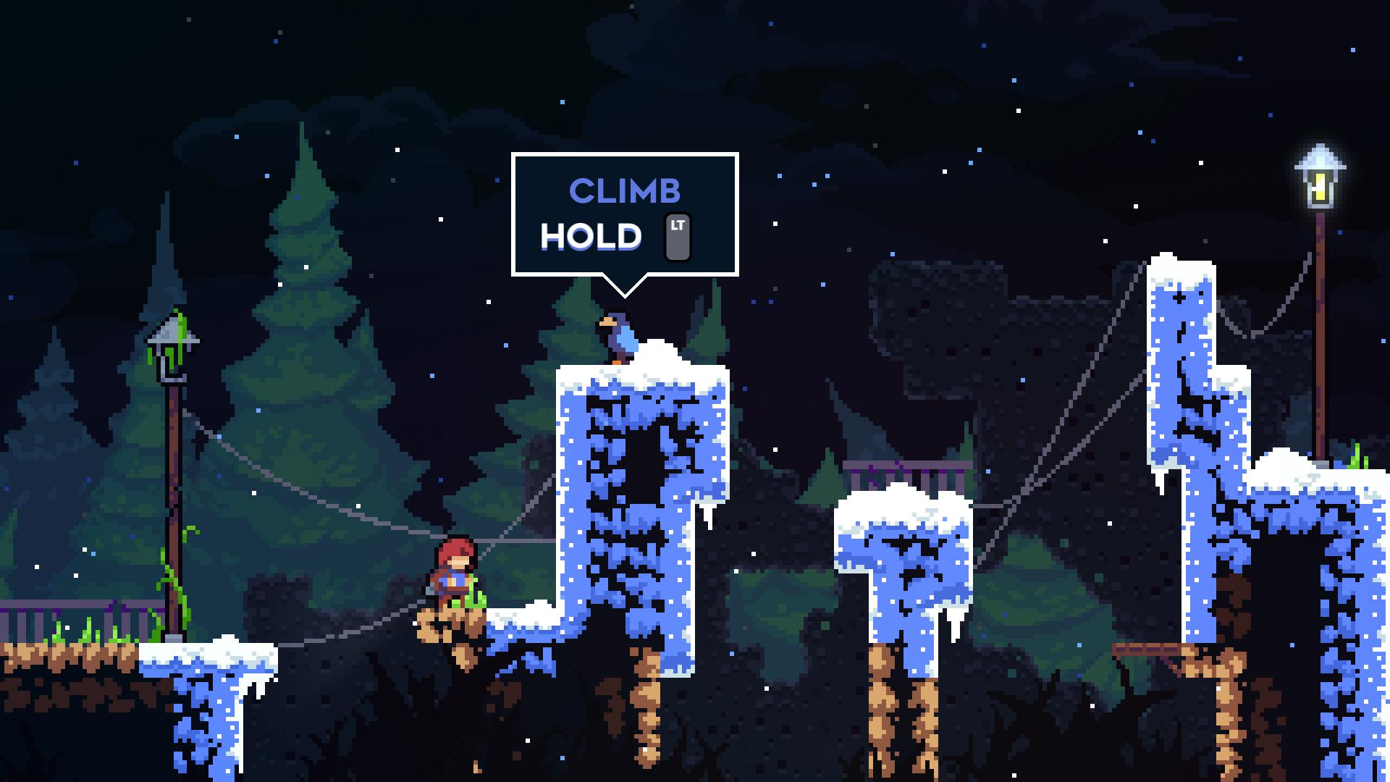
After this brief introduction into climbing, Celeste introduces the story mechanics. Crucially, my game will not include any story mechanics, making it more similar to early platformers, such as the classic Super Mario Bros. series, in order to make the scope of the game much more reasonable.
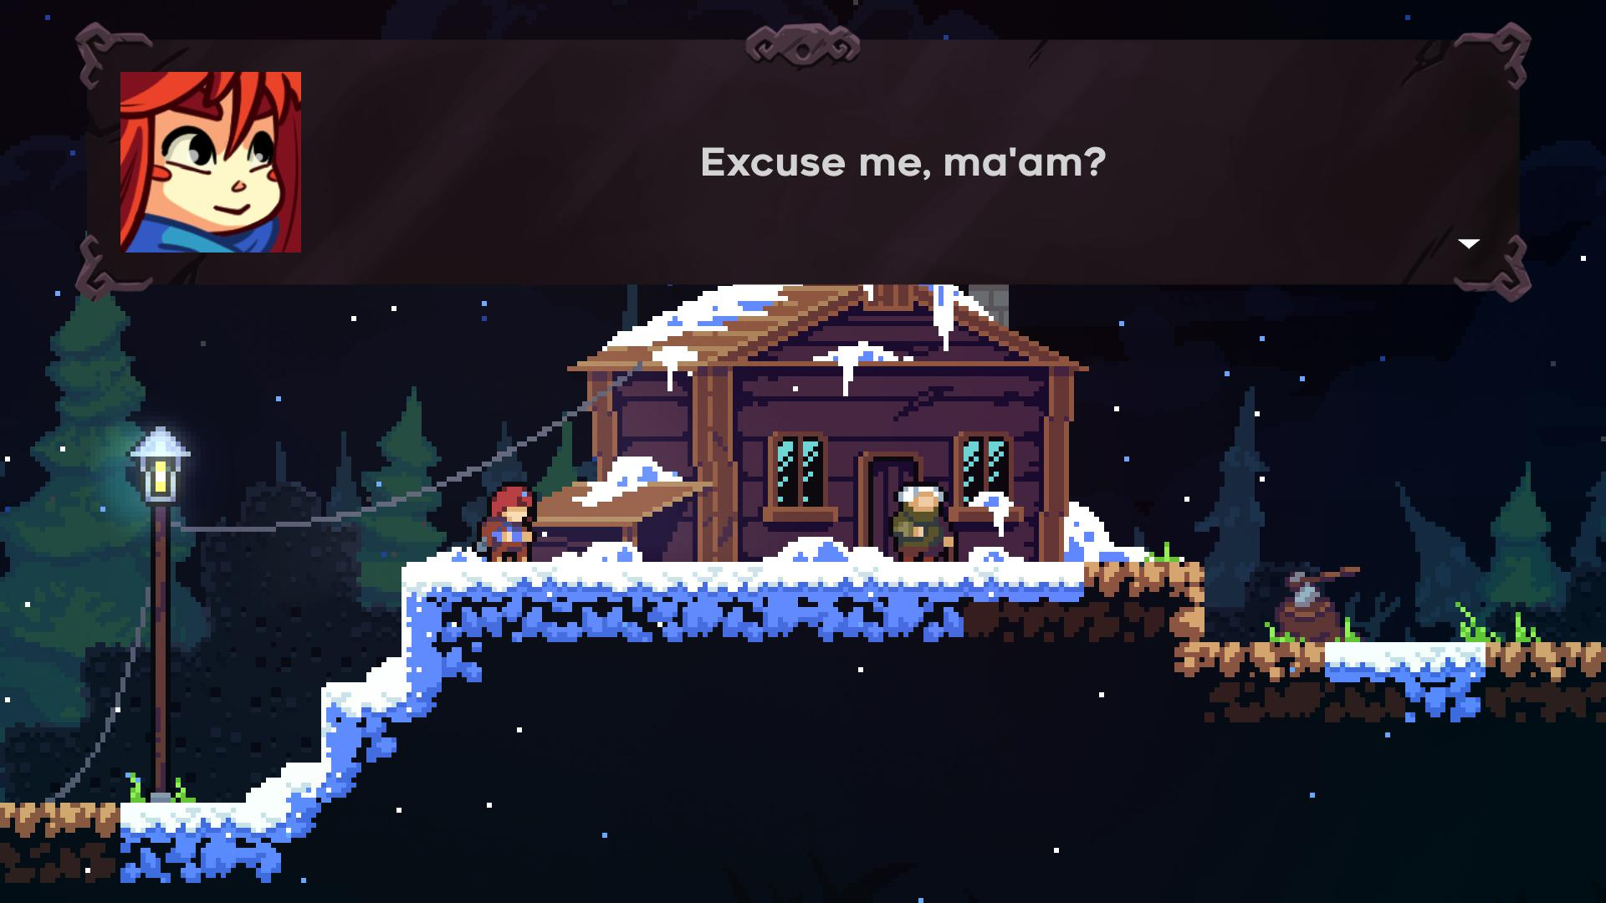
Nevertheless, seeing the story elements of Celeste demonstrates another important factor: accessibility. Even though it would be more thematically appropriate to use a pixelated font, due to the large amount of text in Celeste, having an easy to read, vector-based, sans-serif font will avoid any problems for players with visual or reading difficulties (e.g., dyslexia).
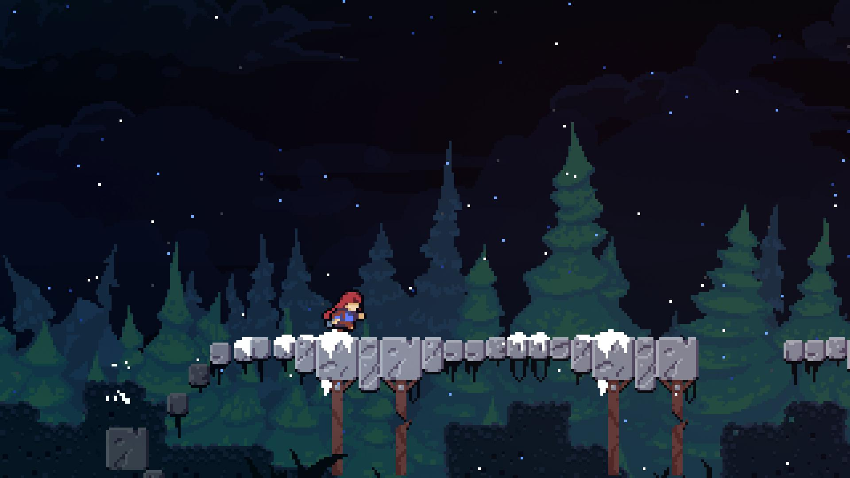
Afterwards, the tutorial continues with a more fast-paced section, involving fairly easy jumps, just to gradually introduce the player to the action side of Celeste’s gameplay. Crucially, this is where the dash mechanic is introduced: Celeste’s main “gimmick” (just as my game’s main gimmick will be the rope-swing mechanic). An important thing to note is that the dash mechanic is disabled until it is required during this short cutscene:
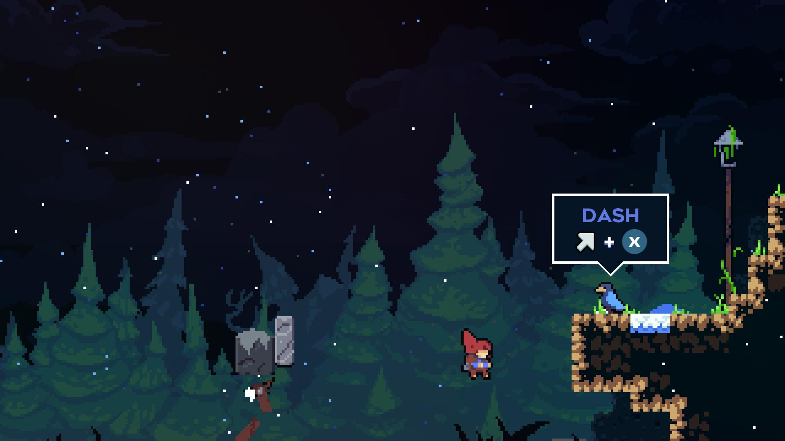
Once this cutscene occurs, the player can finally use the dash mechanic. This short tutorial is well integrated with the story, but also acts as a small level, allowing the player to freely play around with the mechanics until they are comfortable with using them when necessary. It is not until the first chapter of the game where the difficulty increases to a significant level.

The Mechanics in Celeste
Each chapter of Celeste has its own special mechanic, however, in order to avoid too much scope, I will focus my game on only the main gimmick: the rope swing. However, there are some important general platformer mechanics that I plan on implementing from Celeste (and other platformer games).
The jumping mechanics of Celeste include variable jump height, i.e., holding the jump button for longer means jumping higher. This has been a staple of platforming ever since the original Super Mario Bros., making it extremely prominent in almost all platformer games. Without variable jump height, the lack of control often feels “off”.
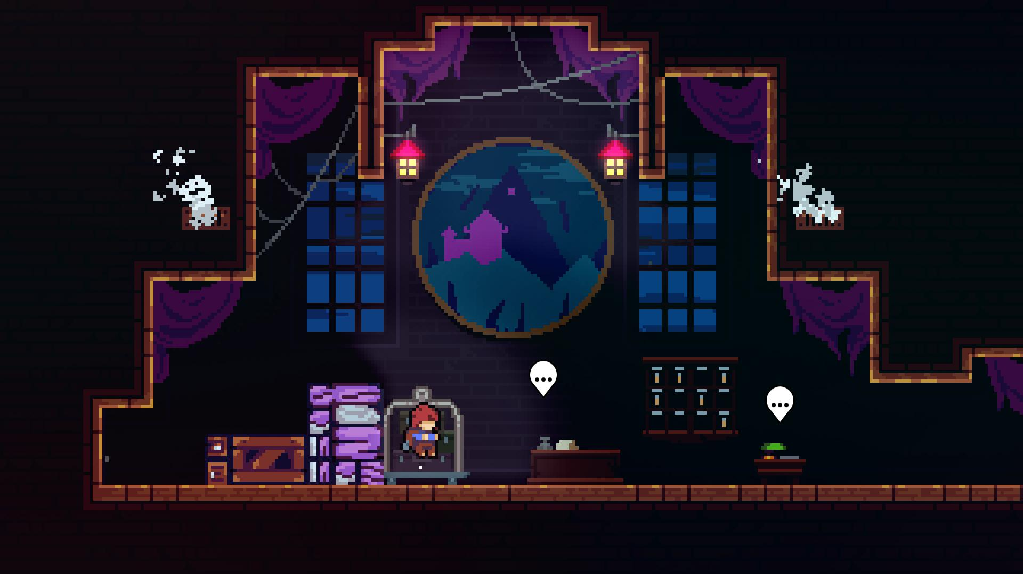
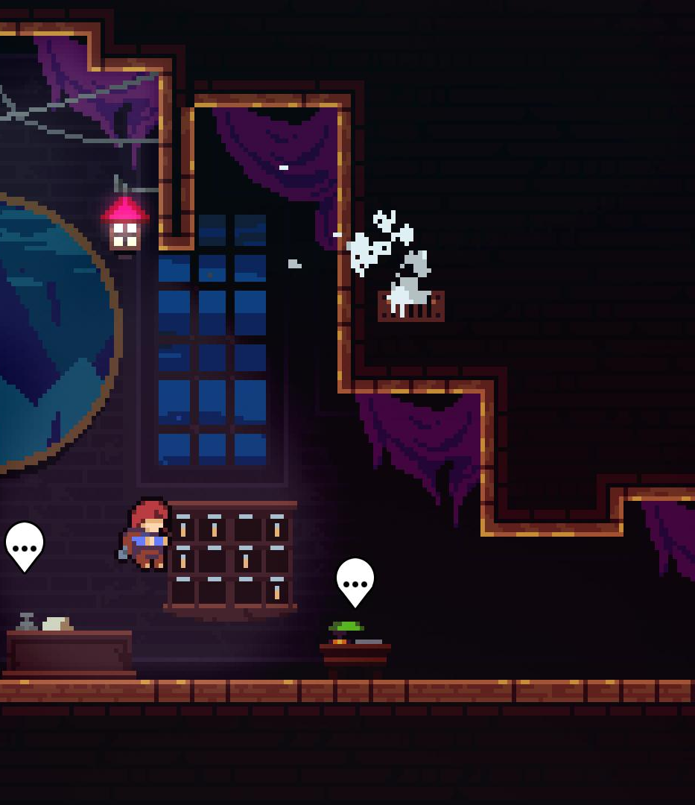
Above shows the minimum and maximum height the protagonist, Madeline, can jump. This is all controlled by the player depending on how long the jump button is pressed. The immense amount of control this gives to the player cannot be understated. Many more of these important jump mechanics can be found in a wide variety of platformer games, such as coyote time, a jump buffer, air brake, a higher down gravity etc., however majority of this will be explained in the design portion of the document.

The Presentation of Celeste, including the User Experience and GUI Elements
Celeste’s visuals are outstanding, particularly due to the balance it achieves from mixing pixel art with modern particles. However, it also keeps a clean look by hiding unnecessary GUI elements from the player, meaning most screenshots (as shown above) contain no GUI at all, meaning only important parts of the GUI are shown when they need to be shown.
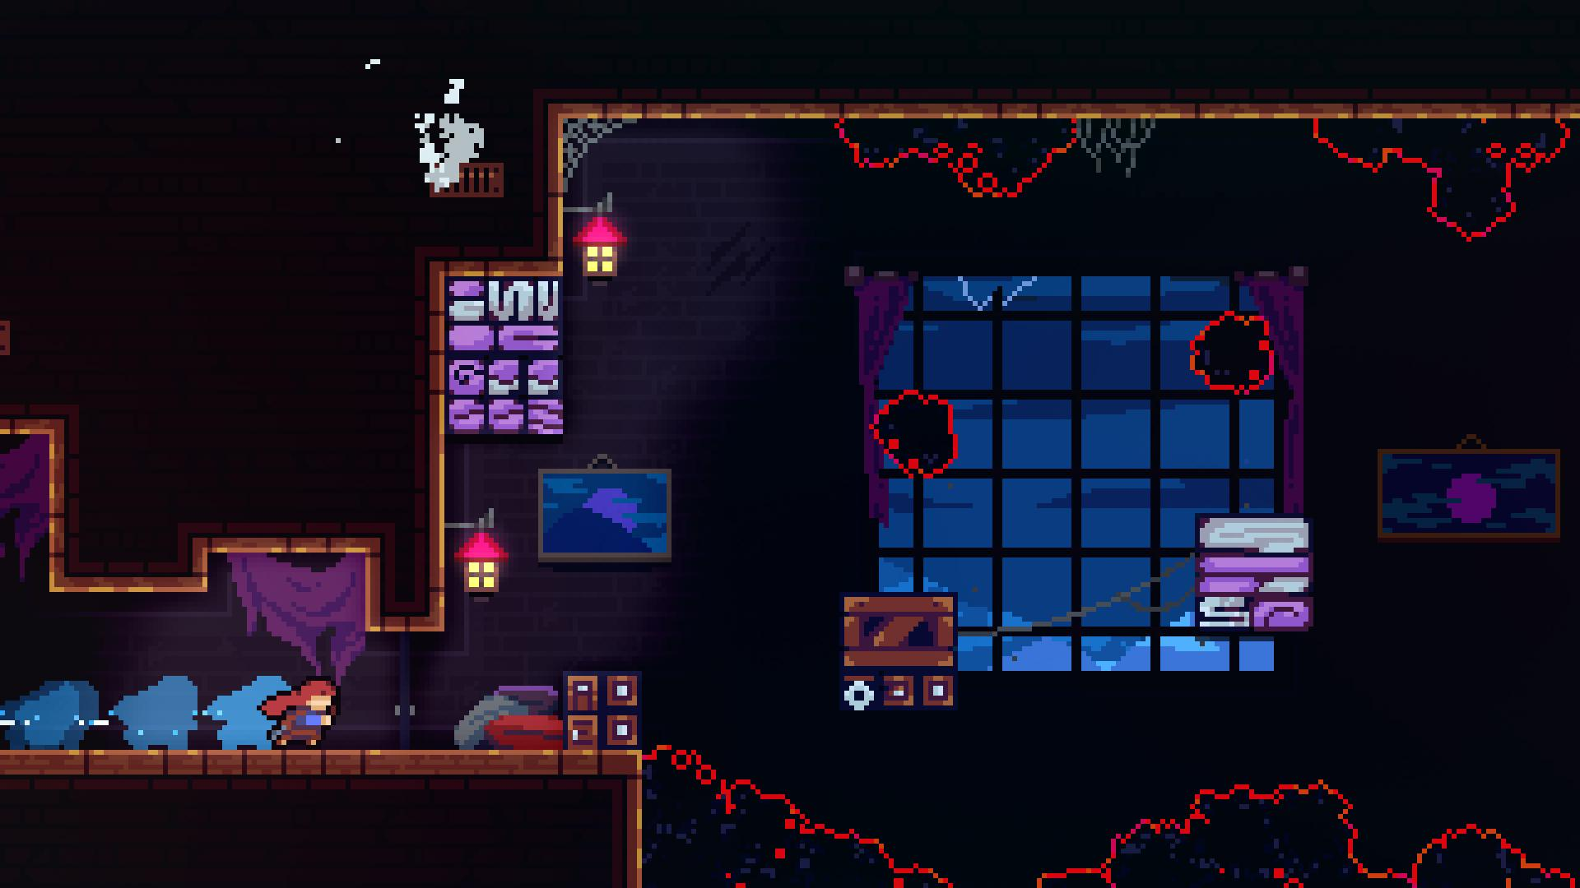
The above screenshot shows no GUI at all, meaning all the user has to focus on is the gorgeous visuals, as well as the platforming action. However, this does not mean there is no GUI at all in the entirety of Celeste. For example, if the game is paused, the number of strawberries (the main collectible of Celeste) is shown, as well as a pause menu.

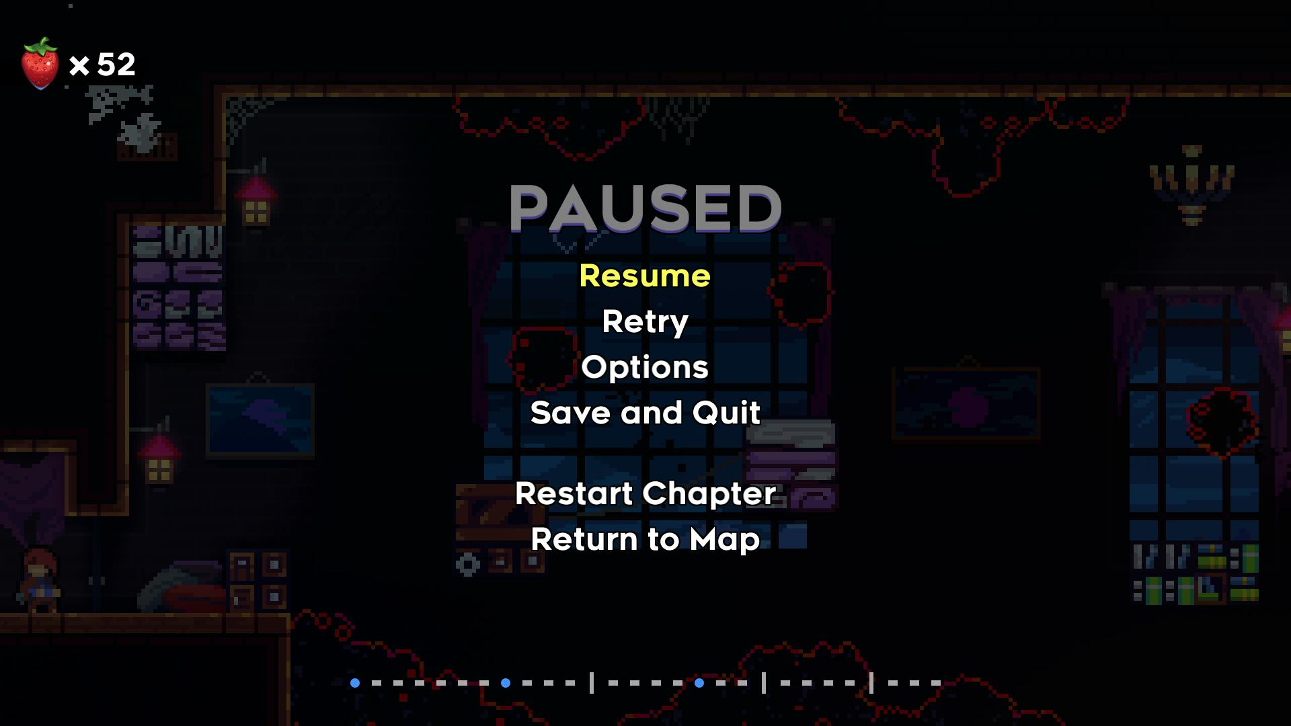
Interview Based on Analysis of Celeste (#1)
To get a good idea on what people, not just myself, like about platformers, I will conduct a 9-question interview on 3 people in my target audience, but still with a variety of ages, to get a wide variety of opinions from a long period of gaming.
- Interviewee 1: Justin T. – Played games mainly in 1980s
- Interviewee 2: Onyx B. – Plays modern games frequently

Question 1: What are you favourite platformer games?
Justin T.:
“[…] one that comes to mind is “Boxer” on the Acorn electron, since it was the first one I ever played […] oh! Prince of Persia!”
Onyx B.:
“Personally, I’m a big enjoyer of games such as Celeste, XΞKINO, Kirby Super Star”

Question 2: Why do you consider said games your favourites?
Justin T.:
“Well Boxer isn’t really memorable for its gameplay, it’s memorable since it’s my first. […] Prince of Persia? Erm, well I suppose I like the isometric view (I suppose it isn’t very isometric, though). I suppose I like how you can grab things, like… I like how you can climb up and down things, unlike other platformers, I suppose. And how some of the platforms give way, so it opens up another part of the world to explore… and there’s also some fighting in it(!). I suppose it’s not very much fighting, but it’s there’s a boss every now and then. I suppose it isn’t really a boss, really, but a guard.”
Onyx B.:
“Well, Kirby, for example, he’s just a little guy. A funky little guy. I mean yeah, I can complete it, and I can play large amounts of it without raging, because I’m not the best at these types of games(!). So, the fact that I can actually succeed on it makes it much more enjoyable. With games like Celeste, the spectacular visuals of the games, the heart-wrenching story of the game really grabs my attention. So, even if I struggle with Celeste, it makes me want to continue trying until I do beat it, no longer how long it takes. I wouldn’t call it unfair. XΞKINO, while the unique idea behind it is just something I’ve never seen before. It really stood out to me.”

Question 3: In terms of platformer mechanics, what do you consider the most important?
Justin T.:
“Erm, I think having variable jumps is important. Like a small jump. A walking jump, and a running […] that’s the most important thing, isn’t it? […] Being able to climb up and down is important, since some of the other games didn’t have that ability”
Onyx B.:
“I mean wall jumping is an obvious simple extra thing to add more opportunities and depth […] Variable jump height, again it really adds more detail, you know. I feel like it gives me more chances to fail, which sounds odd but I kinda like it.”

Question 4: Following your previous answer(s), why are they so important?
Justin T.:
“Well [variable jumps] are important because you can make the world varied, otherwise every single jump would have to be the same distance – the gaps between the platforms would all be the same. Erm, I’ve played games without an up and down feature, as such, where jump was a way to get up to something, but you couldn’t actually go back down, so you couldn’t go back to get something, like a collectible, or treasure, or key, or something.”
Onyx B.:
“I don’t really know what else to say for that [variable jump height]. It’s not really noticeable as a massive extra thing, but it just adds more, so you’re not doing the same, simple, basic things over and over again […] Wall jumps accomplish the same goal.”

Question 5: What platformer mechanics do you see often and dislike?
Justin T.:
“Because I find it difficult to do, I don’t like jumping off vertical walls [wall jumping]. In all games really, I just haven’t been able to do it. […] There was a game on the BBC [Micro B] called “Wizzy’s Mansion”. I think you had 5 lives to start with, but at certain places, […] if you fall more than the height of one [screen] […] it was possible to lose all 5 lives in one go.
Onyx B.:
“To a small extent, wall jumps, but I appreciate their existence, nevertheless. Personally, for me, I dislike timed parts of the games. Like parts where I have to react very quickly, and if I miss something for a split-second, that’s it.”

Question 6: Following your previous answer(s), why do you not enjoy them?
Justin T.:
“Vertical wall jumping, I just found it difficult to do – I just keep falling back down again. Wizzy’s Mansion’s thing was also very frustrating. Especially in a game where you couldn’t save your position.”
Onyx B.:
“I just have, as I mentioned previously, a very slow reaction time, and it’s also a lot easier for me to miss important parts. That’s it really”

Question 7: Are there any interactive mechanics in platformers that have stood out to you?
Justin T.:
Onyx B.:
“Blocks where you hop on them, and then after a certain amount of time they fall below you. Yes, they are timed, but they’re still easier to get past. So, it adds more, but with less frustration.”

Question 8: Do you find that the difficulty of platformer games is well-balanced - why?
Justin T.:
“No… I think they can get very difficult very quickly. Some of the older games don’t really have levels that are truly different – they just make it “harder”. So, they just speed things up, don’t they, or just give you less time to do it. And it gets to the point where you have to be a very fast player to beat a level. But then the ones where the levels are different, they’re not necessarily in order of increasing difficulty. They usually start of easy (on level 1), then you could have level 2, which is more difficult than level 3. […] Mineshaft? […] is a single screen per level platformer (which most retro games are). But, on this one, you can skip levels, […] you can just play the levels you like too.”
Onyx B.:
“It depends on the game. […] Kirby is made so that it’s easier to play for those who aren’t good at those kinds of games. On the other hand, Celeste is a lot more difficult, but I think that the difficulty with that is an integral part of it.”

Question 9: Do you find that platformer games are accessible to all types of people - why?
Justin T.:
“It depends on the level of difficulty. […] Colour blindness I don’t think is generally a problem in most platformers since there is generally a contrasting colour between what’s a solid platform and what isn’t. Erm, I don’t think, erm, a hearing-impaired person would have a problem.”
Onyx B.:
“Well, there’s the obvious issues with sound and deaf people. So… I think it’s useful to not have any parts of the game depend on sound, obviously y’know. Erm, yeah, sound effects are obviously very nice to have – they improve the experience, they stimulate a sense. But those with hearing difficulties shouldn’t be at a disadvantage. [Photosensitive] epilepsy as well. Not necessarily removing all forms of flash, but at least adding a warning. […] And then also language difficulties, […] you’ve gotta consider the languages it’s available in and translate it.”

Question 10: Anything else you’d like to add that’s related?
Justin T.:
“The most important part is the controls; if that’s good, the second most important part is level design; if that’s good, you’ve got a good game.”
Onyx B.:
“I want some emotional attachment. I want some sentimentality. I wanna feel connected to it. […] it could just be in a really simple, small form. But a little bit of sentimental value real raises the game up for me.”

Review of the Interview
From the above interviews, I have ascertained the following information:
- Wall jumps are difficult, particularly if they are not programmed well – they can either be a well appreciated challenge, or a complete turn off from a game .
- Unique platforming mechanics, such as grabbing onto surfaces, are appreciated, and especially help to stand out in the market .
- Boss fights are appreciated where relevant, but platformer games should not focus on them, unless the entire game is planned around it .
- Variable jump height is integral to platformer games; without it, the controls are poor, and the levels become boring and monotonous .
- The difficulty of platformer games is rarely well balanced; either bad programming leads to unfair deaths, or the difficulty curve is irregular or extremely steep .
- Sound and colours should not be essential for a platforming mechanic to work, but be an additional, non-necessary, layer – accessibility options should be provided for any mechanics that may run into this problem .

3.1.5. Specify the Proposed Solution

Interview based on the Review
After giving a brief summary of the main idea of the game, I asked the following questions to one of my interviewees.

Question 1: What types of control options should be available?
Onyx B.:
“Keyboard and mouse – it’s a good, simple combination; you don’t need a fancy controller or anything extra”

Question 2: What should the primary focus of each level be? For example: reaching the end of the level, defeating all enemies, exploration, etc.
Onyx B.:
“I think reaching the end of the level should be the main focus”

Question 3: Following your previous answer(s), why should each level be like this (if at all)?
Onyx B.:
“Defeating all the enemies is cool, it’s fun, but y’know, it’s about jumping on platforms: it’s a platformer, you gotta focus on the platforms. Enemies are extra… superfluous, as one might say”

Question 4: What type of graphical style should the game be? For example: pixel art, hand-drawn etc.
Onyx B.:
“I want some pixel art – gimme those sweet, sweet pixels”

Question 5: Should a sound effect be played for every player action, e.g., jumping, landing on the ground, or should sound be more subtly used?
Onyx B.:
“More subtly used; I don’t wanna have a headache by the end of me playing the game. They’re nice, but can be annoying if overused”

Question 6: Should any collectibles be in the game?
Onyx B.:
“Yes”

Question 7: Following your previous answer(s), if yes to collectibles, how important should they be to the gameplay?
Onyx B.:
“Not crucial, but an extra thing to keep you wanting to play more”

Question 8: Should there be some way to compare “scores” between players? For example: time, death count etc.
Onyx B.:
“Yes – death count, I like the nice death count in Celeste”

Question 9: Following your previous answer(s), if yes to scoring, how much of a focus should it be compared to just completing the level?
Onyx B.:
“Not a main focus at all. Just a way to see how well I completed it, and add a bit of competition between me and any other players… and to mock my previous self… for my [bad] playing”

Question 10: Would you like to see any multiplayer options, or should it remain singleplayer?
Onyx B.:
“Singleplayer – I feel like multiplayer doesn’t entirely fit the concept of the game, so it’s nice to compare with other people, but not play at the same time”

Review of the Interview – Establishing the Main Features of the Game
From the interview, I ascertained the following features for the game:
- Controls
  - The controls should be keyboard and mouse, since it is much simpler to control and easier to understand.
- Level
  - The main focus of the level should be to reach the end, therefore, progression through the game is linear, and does not require exploration in order to complete it.
  - Non-linear elements of the level can be introduced using collectibles, but these should not be the main focus.
  - Enemies, and other obstructions, are not necessary, as long as the platforming is diverse enough.
- Graphics and Sound
  - The graphical style should be akin to retro games from the 8 to 16-bit era, i.e., a pixelated style, with bright and vivid colours.
  - Sound should be implemented but used subtly. It should not be necessary for progression to hear, but rather as an added bonus.
- Scoring
  - Scoring should be primarily based on death counts, similar to Celeste. It should not be a primary goal to have low death counts, but rather an additional challenge players can decide to take themselves.
- Multiplayer
  - Multiplayer support will not be added as the singleplayer experience can be more refined

Proposed Solution
Feature | Justification
The player will be based off a two-state state machine, meaning different mechanics will be used between the “platforming” state, and the “rope-swinging” state | This will allow for much more fine control over the mechanics of the game during its development, as well as make debugging much easier, since a bug will only exist in one state at a time
The player will be able to “shoot” a grapple towards the direction of the mouse. If it hits part of the terrain, the grapple will “hit”, and the player’s state will be changed into the grapple state | This is a simple solution that allows for an extreme amount of precision and control for the player, since the direction of the grapple can be easily changed using the mouse, instead of being locked to 8 directions using the arrow keys (or similar)
The player will be able to control the angle and the length of the rope after it has “hit”, and the state has been changed | This, once again, is all about providing control to the player. This will provide the main part of the platforming challenge, as basic platforming (similar to Mario games) is not overly necessary for the game.
The player will be able to run and jump in the initial “platformer” state | Whilst basic platforming isn’t strictly necessary (since the main gimmick could be utilised at all times), it is still a useful feature to have as it allows the levels to become much more limited, from a design perspective, as well as providing another layer of thought for the player
Collectibles, such as coins, or other types of power-ups, should be added to the levels | Whilst not strictly necessary, collectibles provide another layer of depth in the game; instead of just getting to the end of the level, different players could challenge each other with tasks such as “collect as many coins as possible within 2 minutes”. This provides a community within the game. Crucially, these are not going to be challenges implemented within the game, due to time limitations, as well as demonstrating that they are just optional
The game should keep track of how many times the player has died: per level, and overall | This, similar to collectibles, provides the community another layer of depth to challenge each other with. A death count is better than a lives system, however, since it eliminates the need to “hunt” for 1-ups, or additional lives, making the game much less frustrating, and something players cannot focus on, if they do not wish to
The “camera” in the game will focus on a central point between the player and the mouse position | This allows for controlling the player to be easier, since moving the mouse will allow looking ahead, and aiming at a piece of terrain far away in the level, providing a larger set of level-design options
When launched, the game should open with a menu, as well as a sub “options” menu | This will allow the player to not have to immediately start playing the game, as well as change any important options, such as music and sound volume
Pausing the game should bring up the options menu | This will allow the player to change important settings without having to completely restart the game, such as whether the game is fullscreen or not. The pause menu should also offer the ability to exit the game to the main menu, and to the desktop
Controls should be able to be “rebound” to different buttons on the keyboard | This will allow the player to play with their preferred keys. For example, some may prefer the arrow keys, whereas others may prefer using W, A, S, D
Custom background music should be present throughout all levels and menus in the game | This will provide the correct “atmosphere” for the game, since a completely silent game would simply lack any character, feeling very empty and unfinished
Sound effects should be present, but subtly used in the game. | This will provide feedback to the player for performing different actions, which is integral in any sort of game. They should be subtly used in order to not overwhelm, distract, or confuse the player
GUI to display the number of collectibles collected, as well as the death count. The GUI should hide when the player begins moving | This will allow the player to visually see their current statistics from any place at any time. The GUI hides in order to not distract the player whilst making more difficult movements, as well as creating a much cleaner look to the game

Hardware Requirements
The minimum hardware requirements are based upon Godot’s (the game engine) requirements. Any requirements listed are the minimum, and should, therefore, work with any more advanced hardware.
Component | Requirement | Justification
CPU | 2.5 GHz  Dual core  32-bit | Whilst the game will be coded using single-threaded logic, a dual core CPU is useful for processing collisions and other built-in functions in Godot.  2.5 GHz will be sufficient to run the game, as the logic is very simple, and most of the CPU power will be taken up processing libraries.
GPU | Support for OpenGL 3.3  Integrated Graphics:  Intel HD Graphics 2500  Discrete Graphics:  AMD Radeon HD 7000  NVIDIA GeForce 8 Series | The game requires the use of OpenGL 3.3 libraries; thus, any graphics cards must support the use of OpenGL 3.3.  All modern graphics cards support higher versions of OpenGL, so the requirement is not difficult to meet.
RAM | 4GB | The game itself is very small; it and its libraries will occupy a small portion of RAM, however, 4GB is required to allow the operating system to process any functions while the game is running.
Storage | 50MB | The game should not occupy more than 50MB of storage. This excludes any pre-installed libraries, such as OpenGL 3.3+.
Input | Keyboard and mouse | The game only supports a keyboard and mouse control scheme; therefore, a keyboard and mouse must be present to play the game.
Output | 60Hz Monitor | The game will be designed to where sound is optional, meaning, only a monitor is required to view and play the game. The game will be designed to run at 60 frames-per-second, meaning a 60Hz (or greater) monitor will be required. Speakers or headphones are recommended but not required.

Software Requirements
The minimum software requirements are based upon Godot’s (the game engine) requirements. Any requirements listed are the minimum, and should, therefore, work with any more advanced software.
Component | Requirement | Justification
Operating System | Windows 7  MacOS 10.10  Linux with X11 or Wayland  32-bit | The game will have both a 32 and 64-bit export, meaning it will run on almost any modern Windows and MacOS machine. All Linux based machines should be able to run it also, although Unix-only machines will not.
OpenGL | OpenGL v3.3 | The game’s graphical back-end is handled with OpenGL 3.3, thus OpenGL 3.3+ is required to handle the game’s graphics

Success Criteria
Requirement | Justification | Reference
Player can run and jump using left, right, and jump controls | Basis of the platformer genre, allowing the player to traverse the various levels | Celeste analysis
Jumping triggers a sound effect | Provides the player with some feedback other than visual | Interview #2
Player can click on a tile to switch to the rope state | Allows the player to switch into the primary rope-swing gimmick | N/A
Switching state triggers a sound effect | Provides the player with some feedback other than visual | Interview #2
Player can swing the rope using left and right controls | Allows the player to control the main rope-swing gimmick | N/A
Rope is affected by gravity in a “pendulum” effect | Provides some challenge to the rope-swing gimmick, as well as adding a small sense of realism | N/A
Player can switch back, from the rope state, to the platformer state using the jump button | Allows the player to switch back into the normal state to make simple movements | N/A
Switching back to the platforming state maintains momentum | Allows the player to swing across gaps further than the rope can go | N/A
Switching back to the platforming state triggers a sound effect | Provides the player with some feedback other than visual | Interview #2
3 unique levels | Allows the player to experience all the mechanics the game has to offer | Interview #1
Coin collectibles can be found throughout each level | Allows for optional competition between players | Interview #2
Coin-count increases when the coin is collected | Allows players to compare coins collected for said competition | Interview #2
Coin-count is saved when the game is exited | Allows the player to return to the game at a later point | Interview #2
Collecting a coin triggers a sound effect | Provides the player with some feedback other than visual | Interview #2
Checkpoints throughout the level | Allows for larger levels, rather than many small levels, without unfair difficulty | Interview #1
Colliding with the checkpoint activates it and deactivates the other(s) | Allows for levels to have multiple checkpoints, rather than just one | Interview #1
Colliding with the checkpoint triggers a sound effect | Provides the player with some feedback other than visual | Interview #2
Player returns to the checkpoint if they die | This is just how checkpoints work. | Interview #1
Death-count increases if the player dies | Allows for optional competition between players | Interview #2
Death-count is saved when the game is exited | Allows the player to return to the game at a later point | Interview #2
Dying triggers a sound effect | Provides the player with some feedback other than visual | Interview #2
GUI showing coin-count in the top left | Allows the player to actually view the coin count | Celeste analysis
GUI showing death-count in the top right | Allows the player to actually view the death count | Celeste analysis
Respective part of the GUI is shown when the player collects a coin / dies | Keeps the general game clean, whilst still providing important information when necessary | Celeste analysis
Transitions when the player enters and exits the level, dies, or the screen changes | Clearly establishes the end of the level, as well as making screen changes look nice | Celeste analysis
Main menu allowing the player to start the game or change options | Allows the player to launch the game without immediately being put into the game | Celeste analysis
Options menu allowing the player to go fullscreen and change the volume of the game | Allows the player to change any important options before the game begins | Celeste analysis
Player can rebind the up, down, left, right, and jump keys | Allows the player to use any preferred keys or keyboard layouts | Celeste analysis
Sprites have a pixel art æsthetic | Keeps consistency throughout the game, as well as matching the retro inspired mechanics | Interview #2
First level should introduce mechanics to the player | Provides a safe level to allow the player to experiment with all the mechanics of the game | Celeste analysis

3.2. Design of the Solution

3.2.1. Decompose the Problem

Systems Diagram
Rope Swing Game
Main menu
Go to saved level
"New game" - start from level 1
Change options
Exit game
Options
Toggle fullscreen
Change volume
Change keybinds
Main game
Pause
Exit
Save when exit
Go to main menu
Change options
Level
Player
Sprite
Collision "hitbox"
Controls
Change controls
Get input left and right
Get input for mouse
Get input for jump
Scoring
Collectibles
Disappear when collected
Add to counter when collected
Death count
Add to level death count
Add to global death count
Tiles
Collision for player
"Autotiling" for level creation
Rope
Cast ray from player to tiles
Get mouse position
Control rope
Change rope angle
Get input for left
Get input for right
Change rope length
Get input for up
Get input for down
Camera
Follow player and mouse
Get player position
Get mouse position
Calculate middle position
Background
Blue background
"Parallax" clouds in background
This systems diagram creates a visual representation of the main features of the game to be implemented. Due to the hierarchical nature of the diagram, the solution outlined can easily be transferred into an object-oriented game engine, of which I have decided to used Godot, as mentioned in the “thinking ahead” section of the initial analysis. This means that each module of the diagram will be a separate problem that needs to be tackled during the development of the game. Planning this out initially sets out the problem in an easy-to-understand way, allowing for a systematic approach to creating the final product.

3.2.2. Describe the Solution

Explanation of the Systems Diagram
The table below contains the main features of the above systems diagram, as well as a brief explanation of the core functionality I plan on implementing.
Component | Explanation
Main menu | The main menu will be the first screen the player is greeted with and will offer some necessary functionality. Having this initial menu means the player is not “thrown into action” straight after launching the program, creating a more enjoyable experience for the player. Moreover, the ability to access options is integral in case the defaults are incorrectly set, which is inevitable for some users.
Options | The options menu will be accessible from two points: the main menu, and while playing the game. This will give the player the ability to change any necessary options, such as whether the game is fullscreen, or the volume, before, and during gameplay.
Pause | The pause functionality will enable the player to pause the game whilst playing. A new pause menu will present options to exit the game, as well as change any options, as previously mentioned. This is integral to a positive user experience, as well as creating a much more polished product, as having a formal way to exit the program is superior to clicking on the close button in the windows environment.
Player | The player object is where majority of the game logic will take place. Since the player is a controllable object, a visual “sprite” is necessary. In order to control the player, inputs will be taken and processed, which will then be used elsewhere in the code for running and jumping.
Scoring | The game will score the player in two categories: the number of collectibles found, and the death count. Both will have to be stored in global variables that do not reset after a level has been completed.
Tiles | The levels in the game will be made up of individual “tiles”, which the player needs to be able to collide with. Additionally, to create high-quality looking levels, auto tiling features will be used to “join” tiles together where necessary, creating a seamless look.
Rope | Similar to the player object, the rope will act as a separate state which the player will follow when in said state. This will allow the user to control the rope’s angle and length. The rope also needs to be able to be created, meaning the mouse input and position needs to be taken.
Camera | The camera will try to keep both the player and the mouse on the screen at the same time by taking the mean average of each position. This will allow the levels to be expansive – more than one screen – as well as make it easier for the user to “aim” the rope at platforms in the level.
Background | A background will be added to create a sufficient aesthetic in the game. “Parallax” scrolling will be implemented, which provides pseudo-depth within the game, making the background feel more significant to the player.

Design of the Menu
When the player first launches the game, they will be greeted with a menu. This is a graphical user interface (GUI), which allows the user to change any necessary settings, as well as play the game. Below is a design mock-up (i.e., very rough and basic version) of the menu design I intend to implement.
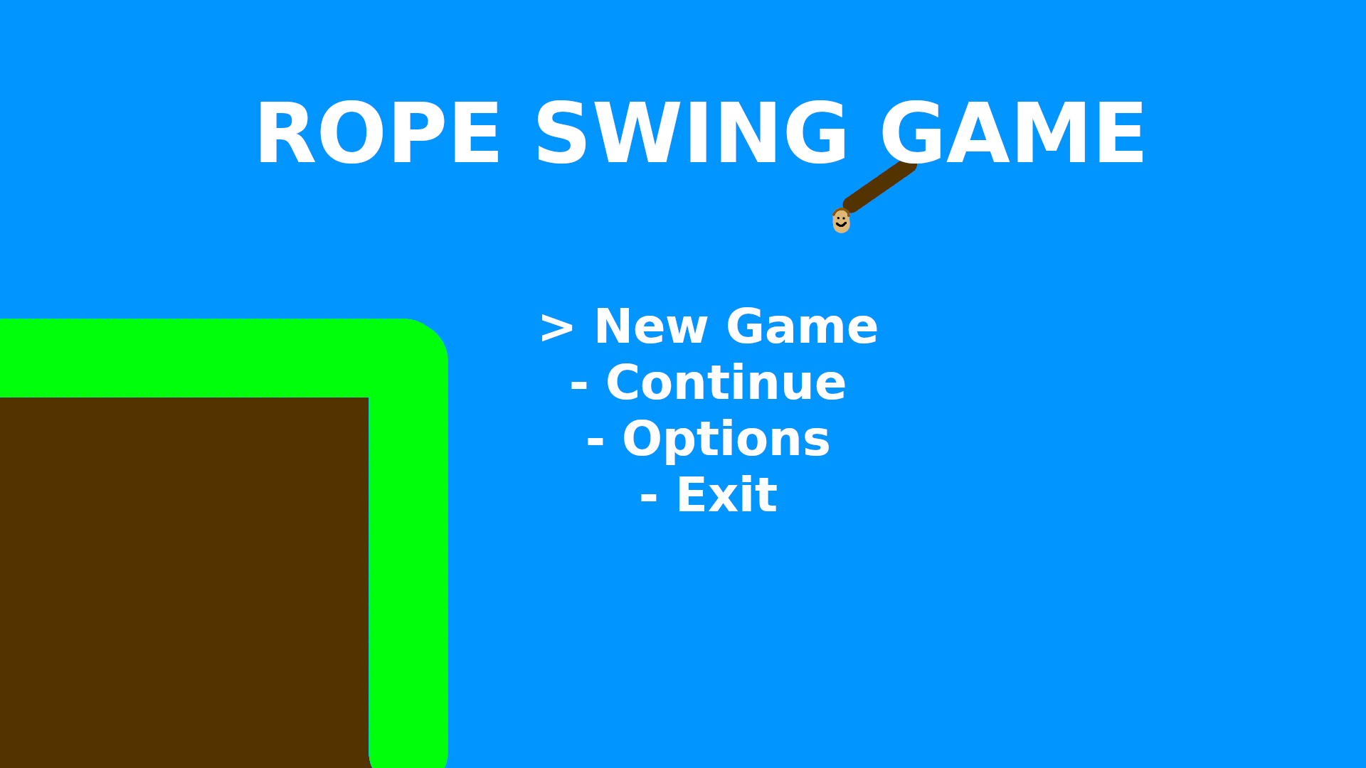
The above is a design mock-up of the main menu. The general layout will be replicated; however, the name and overall design is subject to change (obviously). The menu is simplistic to allow the user to easily understand what each option entails and contains a small image of the player sprite to add some additional personality to the menu screen, instead of a blank image. In game sprites will be used in the final game.
The new game button will lead the player into the first level. I plan on having a linear progression, meaning there will not be a “world map” screen. Continue will lead the player into the last level they played, meaning it will be missing when the game is loaded for the first time. The options button will lead to a new menu consisting of basic option settings, and exit will end the game. To select an option, the currently bound up and down keys can be used. The “>” character represents which option is currently selected in this mock-up.

Design of the Options Menu
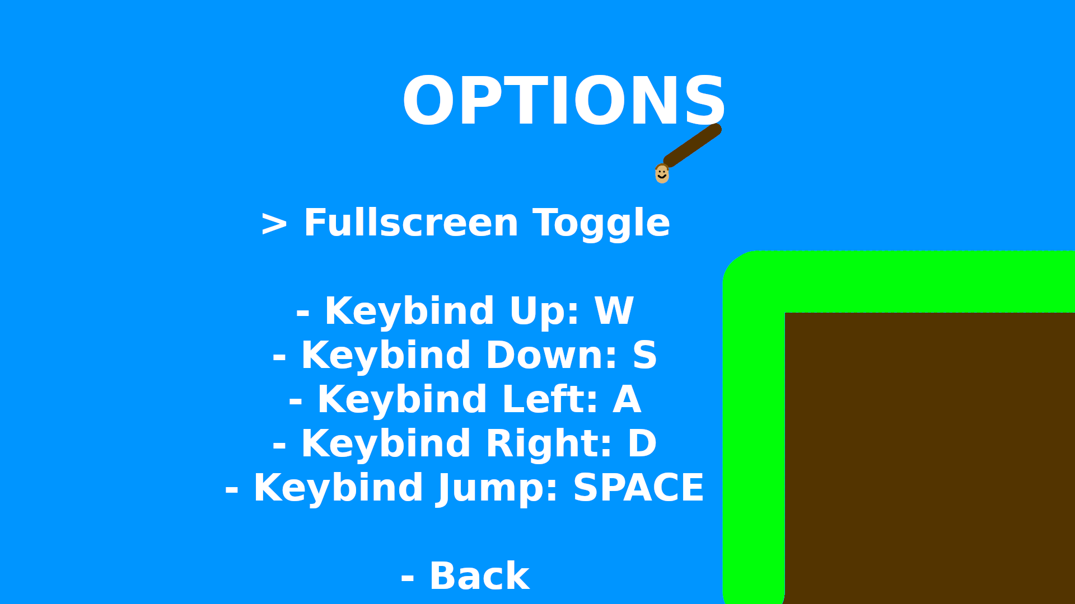
Above is a design mock-up of the options menu. This will be separate from the main menu in order to make it easier to distinguish between. The options menu will have options to change the volume of music and sounds separately, as well as toggle between the window being fullscreen, and in “windowed” mode. The change controls option will lead into another menu, to allow a better visualization of the control differences. Once again, in game sprites will be used to create a much better looking, more succinct menu.
By pressing the enter key, the user will be able to rebind all controls. However, since a mouse is required, there is no additional setting to change the use of the mouse pointer, only the mouse button.

Controls
One of the most integral parts of user-end design is the default control scheme. Essentially, this will dictate the most frequently used control scheme, as majority of players will not feel the need to modify it. If this default is poor, it will result in a poor user-experience, meaning it is essential to provide simple to understand and easy to modify controls.
The aforementioned target audience, that being 12+, are likely to own a netbook sized computer, meaning the keyboard layout is that of the Apple Macintosh Keyboards, or those derived from the minimalistic design. This means that there is a high chance that the arrow keys have a smaller layout, making them more difficult, and frustrating to use, particularly for long periods of time.
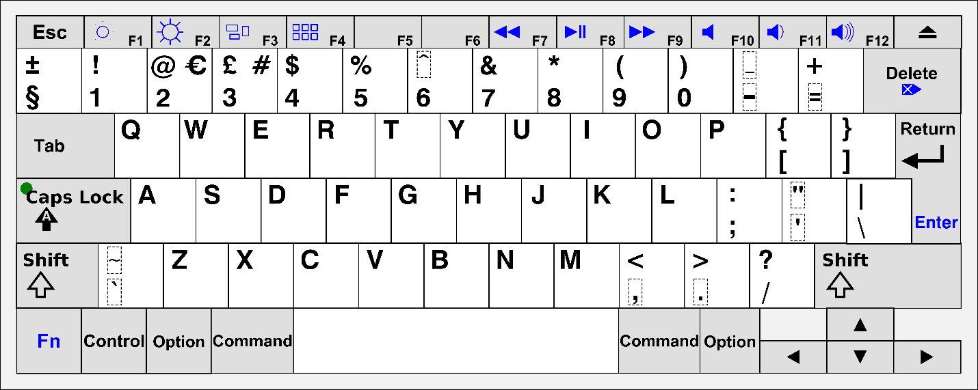
Above is a diagram of the current Apple Macintosh Keyboard layout. Due to the restrictions previously mentioned, I have designed the controls to use the W, A, S, and D keys as a substitute for the arrow keys. These full-sized keys are much more suitable for long periods of gaming, as well as are more suitable for right-handed individuals (of which majority of players will be) since it will be much less cramped if playing with little desk space. It is this reason why rebinding controls is still necessary, as it will allow left-handed individuals with full-sized keyboards to more comfortably play the game; however, default controls must be suitable for all players, thus W, A, S, D will be used.
The game will require additional controls besides four directions. These additional controls will also need to be able to be rebound to other keys, particularly for accessibility and preference. For example, the spacebar will be used to jump, and to “exit” the rope swing. However, many people will prefer to use W or the up-arrow key as jump, so clicking the right mouse button will also “exit” the rope swing.
However, it is impossible to provide the ability to rebind mouse movements, which are integral for the precision required when grappling onto various targets. Because of this, only buttons will be able to be changed in game.
One of the most important points that was raised during the interviews was the problems with the difficulty of platformers. It is integral that I don’t add additional artificial difficulty due to bad controls.

Movement
The most important part of a platformer is, as expected, the platforming physics, and movement. This is why it is integral to plan out how the movement code will work ahead of time, as well as to plan out what different aspects of the movement can be programmed at a later time. This creates a natural ranking of the most important parts of platformer physics, especially when making a fun to control, but still suitably difficult platformer.
Many of these small details can be found in the earliest of platformers, including the original Super Mario Bros., all the way up to modern titles, such as Celeste, or Super Meat Boy.

Running
When dealing with the player’s movement in a platformer, there are 3 important aspects to consider: the maximum running speed, the acceleration, and the deceleration. Although not entirely realistic, it is extraordinarily helpful to have separate values for acceleration and deceleration; a long acceleration and short deceleration can exaggerate the player’s speed, such as in games like Sonic the Hedgehog, whereas a short acceleration and long deceleration can emphasise the “slipperiness”. None of these configurations are bad, but they need to be complimentary to the level design, otherwise the movement will not fit with the platformer.
For my game, I plan on basing my movement similar to Celeste’s, which includes a fairly short acceleration, and an immensely short deceleration, in order to give the player more control. This emphasis on player control makes Celeste feel “tight” to play, meaning if the player fails, it never feels unfair, which was a requirement of mine based on the interviews. Because I want to emphasise the usefulness of the rope-swing mechanic, the max speed for the player whilst on the ground will be relatively low, allowing swinging on a rope to have a greater prominence.

Jumping
Even though the main USP, or unique selling point, of my game is the rope swing mechanic, it is integral that the jumping is well designed, as much smaller actions will be entirely reliant on an easy-to-use jump, that is well suited to the rest of the level design. Similar to running, there are several variables that control a well created jump in a platformer: the jump height, the jump duration (i.e., the gravity), the air acceleration, air control, air brake, and the down gravity. Many of these are self-explanatory, but some are more subtle.
Air control dictates how easy it is to move the player whilst in air, whereas air brake dictates how easy it is to slow down the already moving player in the air, essentially air deceleration.
For my game, because much of it relies upon chaining inputs together to swing off multiple pieces of the level, the jump height has to be high enough to be able to see your next target, but low enough that the rope doesn’t become redundant. Moreover, air movement – i.e., air acceleration, control, and brake – have to be easy enough to manoeuvre but not make the rope controls redundant.
Many newer platformers implement a “down gravity”, which is a gravity multiplier that affects the gravity when travelling downwards. This can make jumps much easier to land, particularly if air brake is low. However, due to the main mechanic of the rope, it is important that the player is in the air for as long as possible, therefore this will not be implemented, as it would make chaining rope swings much more difficult.

Assistance
Platformers can often feel unfair if small and subtle tweaks aren’t added to bias the game in the player’s favour. These tweaks have to be subtle enough as to not make the game easier, but apparent enough to actually have an impact. These small cheats recognise the player’s intention, rather than their exact commands.
Terminal velocity is an important tweak that stops the player from infinitely gaining vertical momentum, making it much easier to control, particularly from high platforms. This value must be high enough that it does not seem like the player “rubber bands”, or instantly slows down, but low enough that it actually makes an impact, so the player does not gain too much vertical velocity. This is particularly useful in my game, since a lower-than-average terminal velocity will allow the player to stay in the air for longer, meaning it is easier to control the player and make their next move.
Rounded corners (or capsule collisions) make it so that it is impossible to miss a jump by a few pixels. For example, say the player is below a block by two pixels – this is indistinguishable to the naked eye. If the player jumps, without a rounded collision shape, the player will hit the block and lose their speed. However, with rounded corners, the player is subtly moved in line with the edge of the block, meaning that small and insignificant errors are disregarded entirely.
When making jumps in a platformer, it is very easy to miss pressing the jump button by only a few milliseconds. Coyote time and a jump buffer can remedy this. Coyote time allows the player to jump a few frames after they have fallen off the edge of a block. This is subtle enough that the player does not think the game didn’t register their input, unfairly, but it does not allow the player to always jump mid-air. A jump buffer is less essential, but still helps to make sure that the game always registers the player’s intended input. When falling towards the ground, if the player presses the jump button a few frames early, usually, the game will not register the jump. However, a jump buffer keeps the jump input in mind, and makes the player jump once they reach the ground, even if the jump button is no longer being pressed. These two small details can make a platformer feel much fairer, which is a primary focus, as mentioned in the interviews.

Animations
Not only is making the actual mechanics an important part, but a good practice of game design is making something that the player will repeatedly do feel good. This can be done by adding various animations, particle effects, and distortions to the player, which make the game feel much more polished and complete. Subtly adding particles for when the player is running, jumping, and landing can go a long way in giving the player an appropriate amount of feedback whilst platforming. Moreover, shaking the screen when creating a new rope will add useful feedback to the player, rather than just a small visual change.

Sounds
Similar to these animations, small sounds for running, jumping, landing etc. can go a long way to adding much more depth to the character’s move set.

Swinging
Of course, the basic platformer mechanics, like described above, is important for a platformer game, but they are not essential for this one; the rope swing mechanic will be front and centre, meaning levels must be designed around the uniqueness of the mechanic.
A swinging mechanic is not as well established as other platformer mechanics, such as running and jumping, however I plan on making rope swinging fit in with said mechanics. As mentioned previously, to provide precision for the player, the rope’s “target” will be controlled by the mouse position on screen. This will allow for extremely precise movement of the mouse, as well as making it easy to quickly and consistently perform sequential rope swings.
The player will be able to control the rope after it has successfully “grappled” on to an appropriate tile. To provide challenge, later levels may include tiles that cannot be grappled on to, as otherwise it would make most obstacles trivial. To control the rope, the player will use the right and left keys, which will increase and decrease the angle respectively. Crucially, to add a suitable degree of realism, whilst also providing a better feeling mechanic, I plan on implementing a “pendulum” system.
The pendulum system will essentially allow the rope to swing from side to side, or settle in the middle, depending on which inevitably feels better and easier to control. This means that, for example, if a player lets go of the right arrow key and the rope was facing towards the right, the rope will be affected by “gravity” and fall back down to a neutral, down-facing position. This is important as it will make the rope feel like the player expects, rather than just a free-floating hovering system. Without a pendulum system, the rope effectively is not affected by gravity, making the game considerably more confusing for new players.

Level Design

To do: some example level designs, and the process of level design. Talk about interfacing the tutorial into the level for the user (or perhaps do that as a separate heading). Mention the level difficulty progression being a key point in the interview
Of course, there is no point to good movement physics without good level design, which is a key component of the design portion of this programming project. Level design doesn’t just come down to where to place a platform, or put a collectible, but it also includes integrating game mechanics, such as tutorials, seamlessly, as to add to the player’s overall experience.

Level Components
Firstly, it is important to establish the various mechanics I plan on implementing into the level, disregarding the player’s own mechanics.
Mechanic | Explanation
Spikes | In order to provide a suitable challenge, there needs to be surfaces that the player cannot land on; this could be via anything from inescapable pits, to pools of a dangerous liquid, to tiles that simply will kill the player. To provide an easy-to-understand mechanic, I plan on using spikes, similar to those seen in games like Celeste, or many Super Mario games. This is because they are instantly recognisable as a hazard, unlike something like a tile, which may not demonstrate danger without an obvious design, such as a skull and crossbones, limiting the art for the game. If the player touches the spikes, they will be killed and reset to a previous point in the level, that being the checkpoint they last touched. This will be one of the many ways the player can die, meaning it also ties into the scoring of the game.
Checkpoints | As I would like longer levels that are not split up into “screens”, such as many levels seen in Celeste, or older, 1980s platformer games, such as Donkey Kong, a checkpoint system will be a suitable solution. This is because it will allow me to place checkpoints in key parts of the level, allowing the player to not have to complete the level from the start every time they die, which would become frustrating in particularly long levels.
Coins | Also to tie in with the scoring system, I plan on implementing coins, as specified in the interview stage of the project, since it will provide another layer of scoring that is not essential is players do not want to hunt for collectibles. This means that those who find trying to collect as many as possible are free to do so, whereas players who prefer trying to complete the level as fast as possible, or with as few deaths as possible can instead focus on that, meaning there is no one way the game has to be played, broadening the target audience.

Basic Tropes
There are a few rules that I will follow for all my levels. Following these should make the game feel difficult, but not unfairly frustrating, which is key in level design.

Trope | Explanation
Consistency | When designing levels, it is important to always make sure each mechanic acts consistently and predictably. For example, jumping into water shouldn’t let the player swim in one instance, and kill them in another. This is because it allows the player to plan out their actions ahead of time, and it does not unfairly put them at a disadvantage for experimenting; when a new mechanic is introduced, the player can quickly figure out whether it will benefit them, or be a detriment to them, and it will stay that way throughout the entirety of the game. This is also why randomised physics should be avoided, as it can make the game’s controls feel inconsistent, as if the player is constantly fighting against them. Crucially, this does not mean that there cannot be any random functions in the game – in fact most games rely upon a small degree of randomisation – but there is a difference between a small amount of randomisation, and so much randomisation that it becomes frustratingly inconsistent.
Screen Space | It is important that the player can plan out their moves, meaning they must be able to see a reasonable number of obstacles ahead of them. This means that, there must never be, for example, a moving platform that comes on and off of the screen, as the player would not know what move to make until the platform comes back. Once again, this can feel frustrating as it artificially adds additional waiting time whilst playing the game, which is supposed to be fairly fast paced. However, in order to expand the options in level design, small camera controls can be added, such as following the mouse around, in the case of this game.
Introduce Simplistically; Expand on Afterwards | To do: Continue this section

Celeste is a game that is commonly referenced throughout this document. It is a 2018 platformer designed, directed and written by Maddy Thorson, programmed by Maddy and Noel Berry. It regarded as one of the best platformers by many, known for graphics, story, and soundtrack, as well as its high difficulty, while still being fair. It has a 97% on steam, and 10/10 on IGN.
Spelunky is a 2008 2D platformer made by Derek Yu, mixing roguelike elements into platformers
Hollow Knight is a 2017 2D Metroidvania (non-linear exploration and progression, a portmanteau of Metroid and Castlevania, two classic 2D platformers) developed by Team Cherry
Shovel Knight is a 2D platformer developed by Yacht Club Games, which focuses more on the action side of platformers
VVVVVV is a 2010 2D puzzle-platformer created by Terry Cavanagh, which focuses on difficult platforming and exploration (as well as having a great soundtrack)
Pokey Poke is an upcoming (release TBD) 2D puzzle platformer focusing on exploration and difficulty, with the main gimmick being the use of a spear for platforming
XΞKINO is a fast paced, puzzle platformer game, created by Primed Pixel Games, aka. Malachy Moran-Tun, for the GMTK 2021 Game Jam. It uses a central mechanic of two players being “tethered” together, in which that tether can destroy enemies, as well as interact with other parts of the game.

